The purpose of Social Prescribing
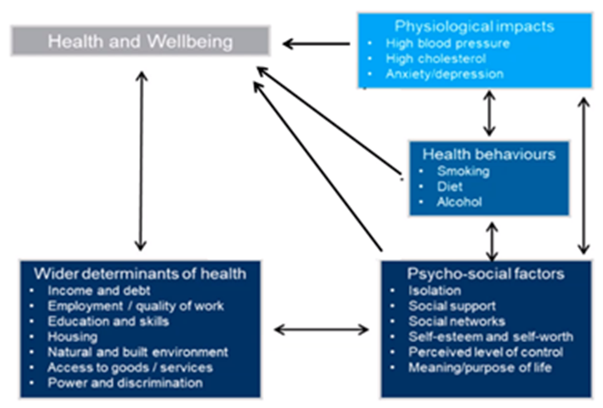Social prescribing empowers people to take control of their health and wellbeing through referral to non-clinical social prescribing link workers. They give people time to focus on what matters most and take a holistic approach to an individual’s health and wellbeing. Working within a biopsychosocial framework, we coach people around what matters to them and support them to set goals they can work towards and achieve. We provide personalised behaviour change interventions to build on people’s knowledge, skills and confidence.
Link Workers in the Primary Care Network Teams:
- Take a whole population approach, working with a range of people who may benefit from social prescribing, including people who are lonely, have complex social needs, low level mental health needs and long-term conditions
- Help people to identify issues that affect their health & wellbeing, and co-produce a simple personalised care and support plan
- Support people by connecting them to non-medical, community-based activities, groups and services that meet their practical, social and emotional needs, including specialist advice services and arts and culture, physical activity, and nature and green based activities
- Use coaching and motivational interviewing techniques to support people to take control of their own health and wellbeing
- Support development of accessible and sustainable community offers by working in partnership with VCSE organisations, local authorities and others to identify gaps in provision, and take a community development approach to enabling growth in community activities and groups.
Link Workers in our Pathways team also:
- Promote the service and identify new opportunities to expand
- Identify new opportunities to respond to population-level needs
- Build access to social prescribing in under-served communities
- Work across the locality, and with internal and external colleagues, on innovative projects to test new interventions
Expectation
Work unsupervised in a professional manner that promotes excellent person care and experience, while recognising professional and organisational requirements and boundaries. Regularly review risks, as an individual worker and as a team, and issues that could impact on individual care and wider service delivery. Actively engage in supervision and training with a commitment to personal development.
Build relationships with our partners who introduce people to us and to those we introduce people to. Ensure accurate reporting and data collection and contribute to the promotion of our work. Adopt our quality improvement methodology and seek to continuously improve our processes and systems to increase the experience and outcomes of our stakeholders.
Undertake any reasonable duties/responsibilities required to meet the needs of the developing service with a flexibility to work weekends and evenings if required. Contribute to the development and delivery of our high-quality behaviour change training programmes.
This list is not intended as an exhaustive list of duties and responsibilities. The post holder will be asked to carry out other duties which are appropriate to the skills of the post holder and grade of the post as the priorities of the service change.
Deliver our quality standards (full-time equivalent):
- Engage a minimum of 200 people within any 12-month rolling period.
- Attend a personalised care and support plan conversation (PCSP) (new or review) with at least 25 people each complete working week.
- Complete an initial PCSP assessment within 15 working days of the referral date with at least 95% of people who engage.
- Complete and record an initial outcome measure with at least 90% of people who engage, and follow-ups at regular intervals and / or on closing.
- Close at least 95% of the people they work with within 12 months of the referral date.
- Deliver an increasing number of conversations face to face.
- Review each case after 6 PCSP sessions, and every multiple of 6 sessions thereafter. Best practice would see this performed with a peer or in supervision.

